**Module 9**

Apply data augmentation techniques(rotation, zoom, width shift , height shift and horizontal flip) for the following images

import cv2

img = cv2.imread('C:/Users/Lenovo/Downloads/Study material/AI/Convolutional Neural Network/Assignment/000001.jpg')

num_rows, num_cols = img.shape[:2]

rotation_matrix = cv2.getRotationMatrix2D((num_cols/2, num_rows/2), 30, 0.7)

img_rotation = cv2.warpAffine(img, rotation_matrix, (num_cols, num_rows))

cv2.imshow('Rotation', img_rotation)

cv2.waitKey(0)

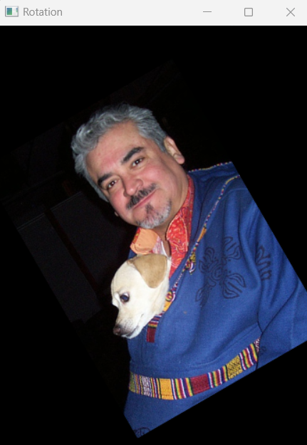

import cv2

img = cv2.imread('C:/Users/Lenovo/Downloads/Study material/AI/Convolutional Neural Network/Assignment/000456.jpg')

cv2.imshow('Original Image', img)

img_scaled = cv2.resize(img,None,fx=1.2, fy=1.2, interpolation =cv2.INTER_LINEAR)

cv2.imshow('Scaling - Linear Interpolation', img_scaled)

img_scaled = cv2.resize(img,None,fx=1.2, fy=1.2, interpolation = cv2.INTER_CUBIC)

cv2.imshow('Scaling - Cubic Interpolation', img_scaled)

img_scaled = cv2.resize(img,(450, 400), interpolation = cv2.INTER_AREA)

cv2.imshow('Scaling - Skewed Size', img_scaled)

cv2.waitKey(0)

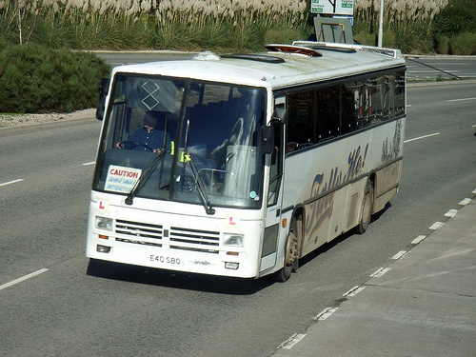

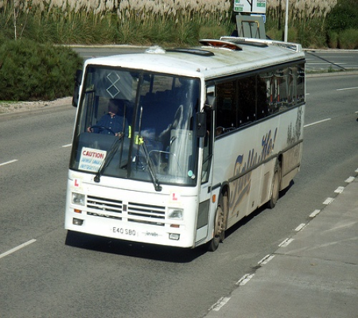

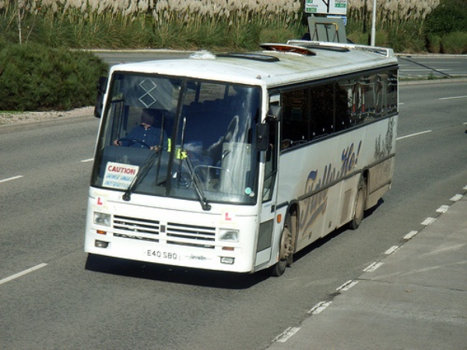

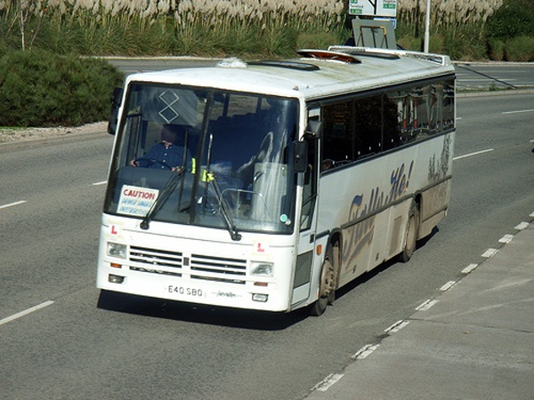

import cv2

# Load the image

img = cv2.imread('C:/Users/Lenovo/Downloads/Study material/AI/Convolutional Neural Network/Assignment/004545.jpg')

# Perform width shift

width_shift = 50

height, width = img.shape[:2]

img_width_shift = img[:, width_shift:] # Shift to the right

img_width_shift = cv2.resize(img_width_shift, (width, height))

# Perform height shift

height_shift = 50

img_height_shift = img[height_shift:, :] # Shift downwards

img_height_shift = cv2.resize(img_height_shift, (width, height))

# Perform horizontal flip

img_horizontal_flip = cv2.flip(img, 1) # Flip around y-axis

# Display the original and augmented images

cv2.imshow('Original', img)

cv2.imshow('Width Shift', img_width_shift)

cv2.imshow('Height Shift', img_height_shift)

cv2.imshow('Horizontal Flip', img_horizontal_flip)

cv2.waitKey(0)

cv2.destroyAllWindows()

